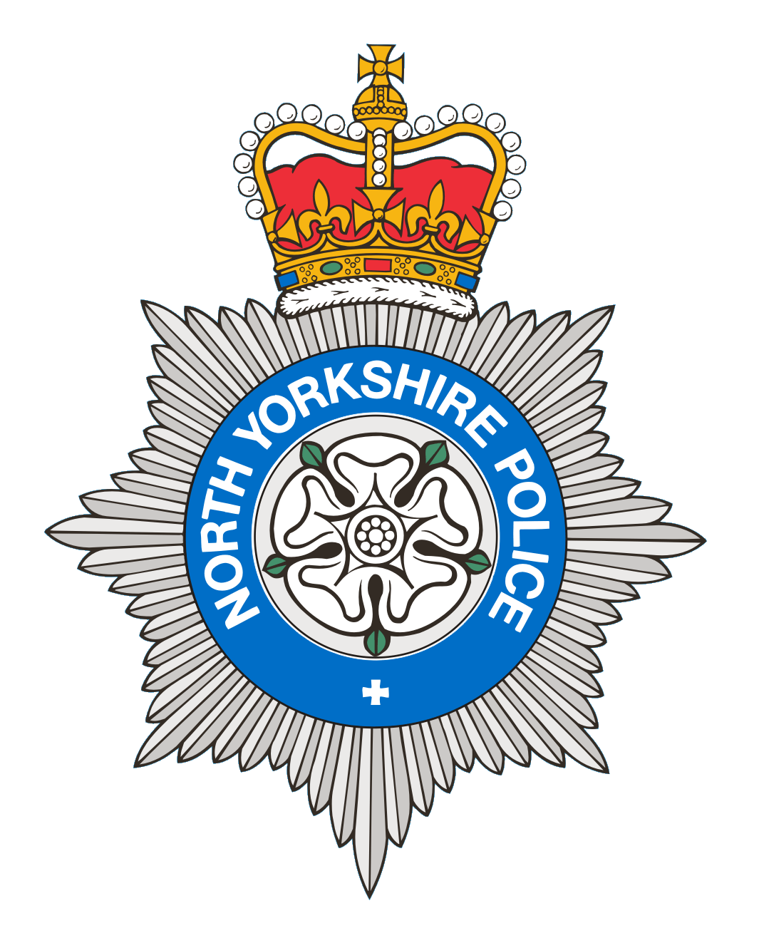
PCSO 3521 Diane Smith
Produced: 18th September 2025
Date of meeting- 16th September 2025

BROUGH WITH ST GILES
PARISH COUNCIL MEETING 16th September 2025
POLICE REPORT

14/08/2025 – 18/09/2025

Please note that under the police crime reporting system, all reports of criminal activity are recorded as crimes. However, if at a later date it is ascertained that no crime has been committed, this will not show on parish council report due to time delay.

Crimes = 3
1 Report of Crime Violence which was regarding threatening texts, 1 Report of Criminal Damage, which was graffiti painted on the roundabout, 1 report of Theft of a kids bicycle.
Reported crime for the same period last year = 10

Anti-Social Behaviour = 4
2 ASB Nuisance – 2 Reports of an off-road vehicle riding in the field. 1 ASB incident regarding youths caught in a derelict building by officers on patrol. 1 ASB personal report concerning a road rage incident.
Reports of ASB for the same period last year = 3

OTHER REPORTS includes Highway Disruption and RTC’s

1 Administration – Advice given regarding a domestic situation.

1 Highway Disruption - 1 report of a vehicle obstructing a pavement, which is an ongoing issue.
Other reports for the same period last year= 4

Personal/Safety/Warning Incidents = 7

1 Report of concern - 1 report for a male, he was found safe and well.

3 Reports of Suspicious behaviour – 1 report of 2 vehicles acting suspiciously near to the building site, area search made, no vehicles found. 1 report from a resident who was concerned regarding a group of youths near to her property, youths left after a short while. 1 report of a male riding a motorcycle in a field.

1 Reports of Domestic Incidents.
1 report of an abandoned call
1 report of a missing person
Other reports for the same period last year = 16

Community Messaging
North Yorkshire Community Messaging allows members of the public to register to receive alerts, crime notifications and community news from organisations. It is a way of maintaining contact with Neighbourhood Watch and Rural Watch groups. Neighbourhood & Rural Watch have their own database within community messaging for their members.

​You can sign up to receive alerts as a member of the public here:
https://www.northyorkshirecommunitymessaging.co.uk/

If you wish to speak to your local Neighbourhood PCSO you can send an e-mail to PCSO3521 Diane Smith diane.smith@northyorkshire.police.uk phone 101, choose option 2, and follow the prompts.

